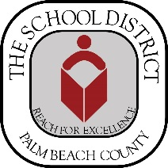
Free immunizations
Welcome Center

- Immunizations for children ages 2 months through 12th grade

- Bring child’s immunization records

wednesday, July 5,12,&19 2023
8:00 AM – 10:00 AM Sign-In/Register Onsite (Limited Space Available)
Immunization services begin at 10:00 AM
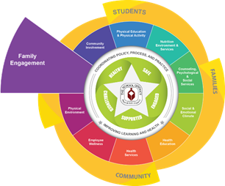
Welcome Center
3300 Forest Hill Blvd. Building E - 50-116
West Palm Beach, FL 33406
561-434-8197

New student registration

Bring the following:
- Two current documents reflecting the correct residential street address

- Florida Certification of Immunization

- State of Florida School Entry Health Exam

- Proof of birth (birth certificate, passport, religious records)

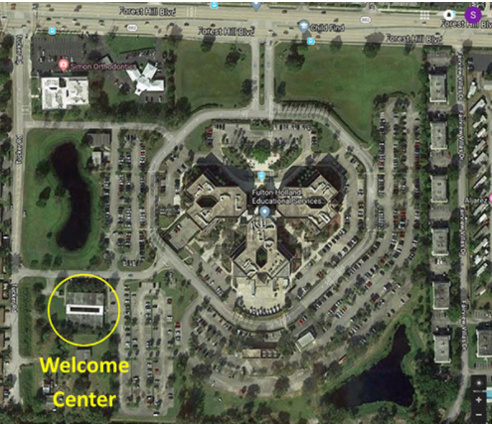
Sponsored by
- The Palm Beach County Childhood Immunization Coalition

- Palm Beach County Health Department

